To: George Khazanov

From: Conrad Schiff

Date: Sept. 5, 2016

Re: FPI data and its uses

## How FPI Data Works

The Fast Plasma Investigation instrument consists of four electron and four ion, dual head spectrometers distributed 90 degree apart from each other on each MMS spacecraft such that there is a dual electron and ion head along each coordinate axis.

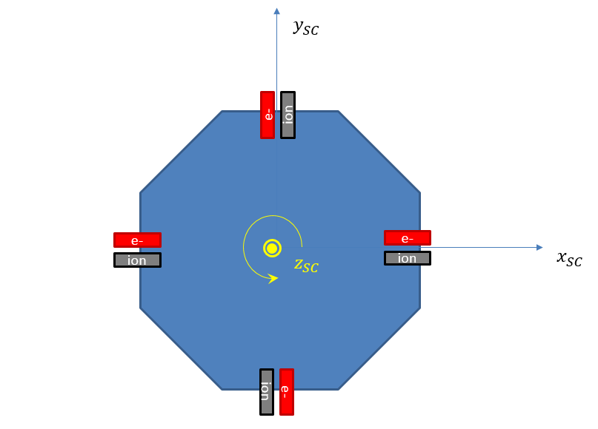

Each head has 16 pixels that span the spacecraft +z-axis to –z-axis in steps of 11.25 degrees.

Through four deflection voltages, the eight ion and electron spectrometers are able to cover the full sky in 32 ‘pixels’ in the azimuthal angle with widths also of 11.25 degrees. The measurement is then a skymap with 18x32 = 512 pixels, which for technical reasons associated with how the data are packed into the CDF, are presented in transpose form as shown here:

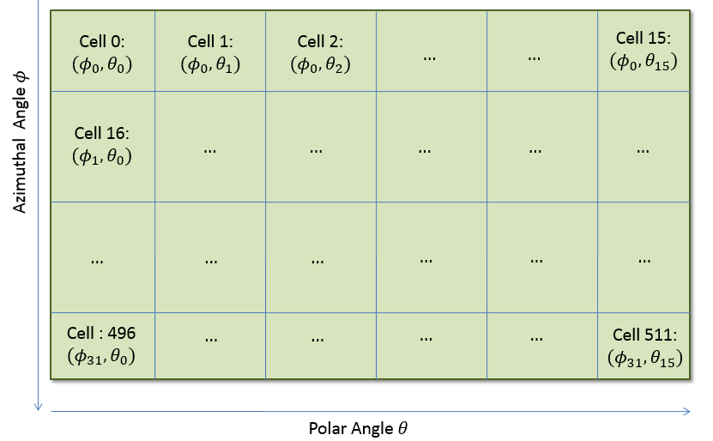

Each pixel can be specified either by a unique cell index of with an ordered pair of azimuth and polar angles (.The translation between one and the other scheme is affected by first letting the index label the cell and the indices label the azimuthal and polar angles. Then the translation, , is given by .

The raw measurements are counts per cell. As the energy is varied, the counts in each cell naturally vary based on the plasma population. This leads to the concept of a stacked set of skymaps

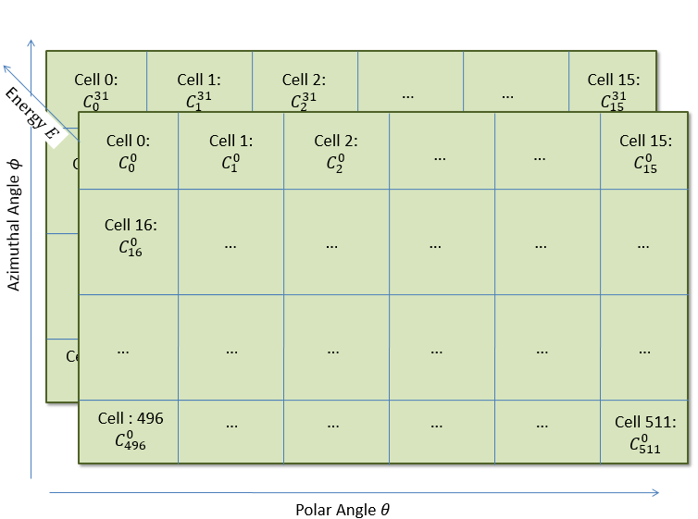

## Frames of Reference

The raw measurements are taken in the spacecraft’s body frame defined as follows. The spacecraft z-axis is nearly along the ecliptic pole, never deviating more than about 2.5-3.5 degrees. To an extraordinary good approximation, the spacecraft spins about this axis at a spin rate of about 3.05-3.10 0.02 rpm (the variation in range is due to different operational scenarios and is deterministically known at any given time).

FPI ground processing ‘despins’ the data by using the pseudo sun-pulse telemetry from the star cameras to give fast survey data (4.5-second integration time) in despun body coordinate (DBCS). The DBCS coordinate system is defined in the MMS Alignment and Coordinate System document (461-SYS-SPEC-0115C) in terms of the spacecraft-to-Sun vector

and the corresponding unit vector

and by the equations

and

The vector is the instantaneous spacecraft body z-axis (i.e. the geometric axis used to define instrument mounting and related metrology).

This coordinate system is closely related to GSE defined using

where is the ecliptic pole at the J2000.0 epochand is the instantaneous vector from the Earth to the Sun. The relevant geometry is shown below (along with additional vector used by FPI).

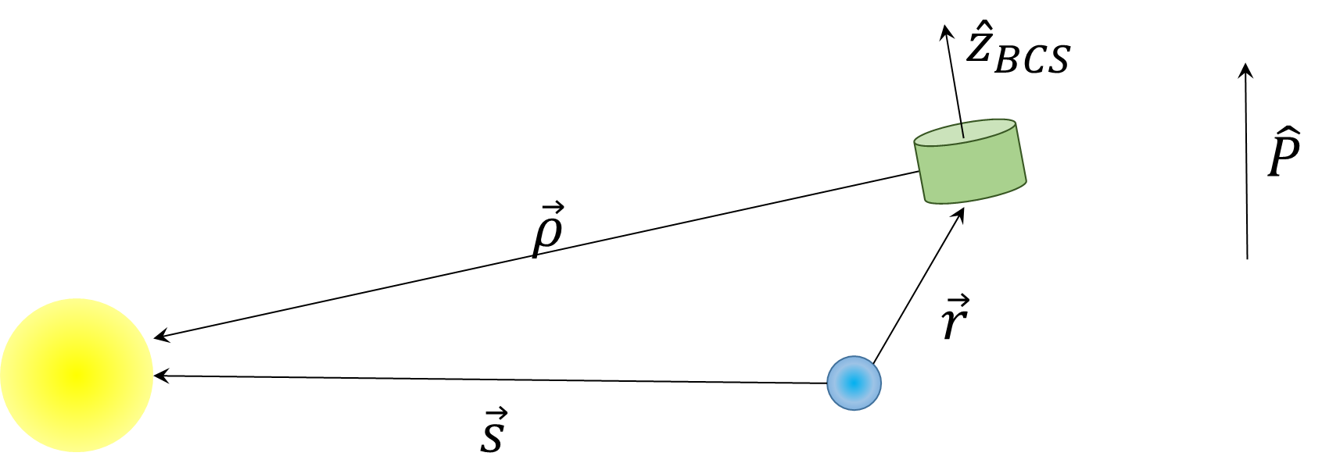

Neither of these coordinate systems have the local magnetic field align with any of the coordinate axes but are they are the primary coordinate systems used to report spacecraft-mounted instrument measurements.

# Exact Conversion from DBCS to GSE

FPI science and engineering data are referenced (where appropriate) to the Despun Body Coordinate System (DBCS)

In order relate the GSE and DBCS frames to each other, the basis vectors from one frame must be expressed in terms of the basic vectors of the other. In a simulation, this can be done ideally at any time step once the orbital and attitude motions are known.

In operations, these parameters are only available from ‘look-up tables’ that list the position and attitude at discrete time steps. Interpolation of some kind is always needed. In addition, large data entry files are required that make file management difficult.

A reasonable approximation that circumvents most of these difficulties is as follows.

Assume that the parallex caused by assuming the spacecraft coincident with the center-of-the-Earth is small. Then the DBCS frame is approximated by

Then the transformation from DBCS to GSE is expressed as

This approximation would then only require the sun ephemeris and the spacecraft attitude (specifically the right-ascension and declination of , which is a slowly changing function of time. This is the conversion that is used by FPI to move instrument data from DBCS to GSE or vice versa.

## Pitch Angle Distributions

The magnetic field is reported by the Fields instrument in either GSE or DBCS (depending on context). Pitch angle distributions are most easily calculated in DBCS by taking the defined magnetic field at the sample time and taking the dot product between it (normalized) with the incoming particle direction for the cell, given by:

Thus 512 pitch angles are generated, at a given time, by

Since the spectrometers measure counts/cell for one of 32 energies ranging from 10 eV to 30 KeV, in fact there are 512 pitch angle distributions generated over each integration time with counts at a given energy , where is the energy label.

The results can be visualized in many ways, but currently there are two basic plots. The first is a slicing of the results as energy is varied within a specific range of pitch angles (called Binned PADs):

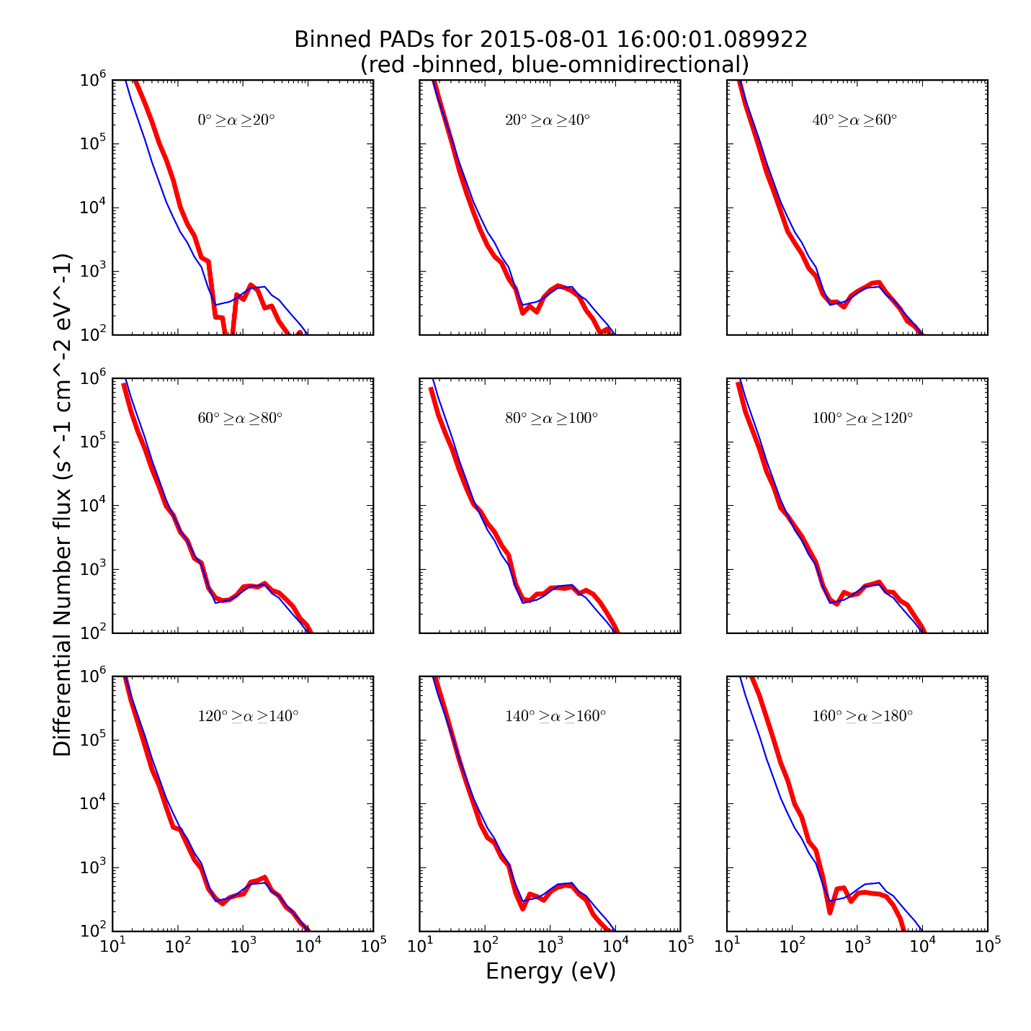

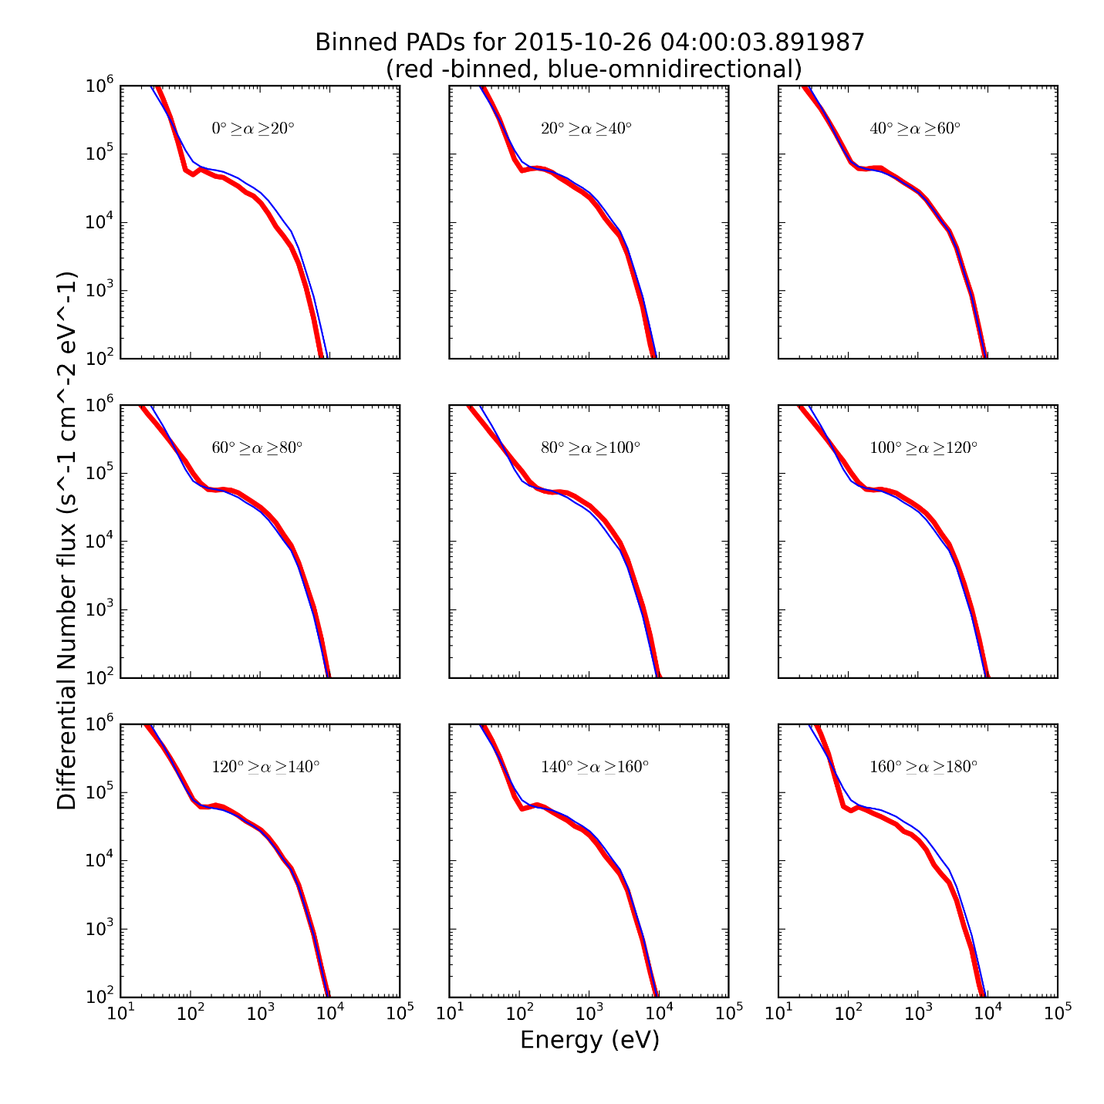

The values for these are obtained as

where is the set of pixels in the desired bin (e.g. pixels with pitch angles between 0 and 20 degrees) and is the number of pixels in this set, is the nth energy, and are the counts in each of these pixels.

Or energy-stacked pitch angle distributions (called Stacked PADs)

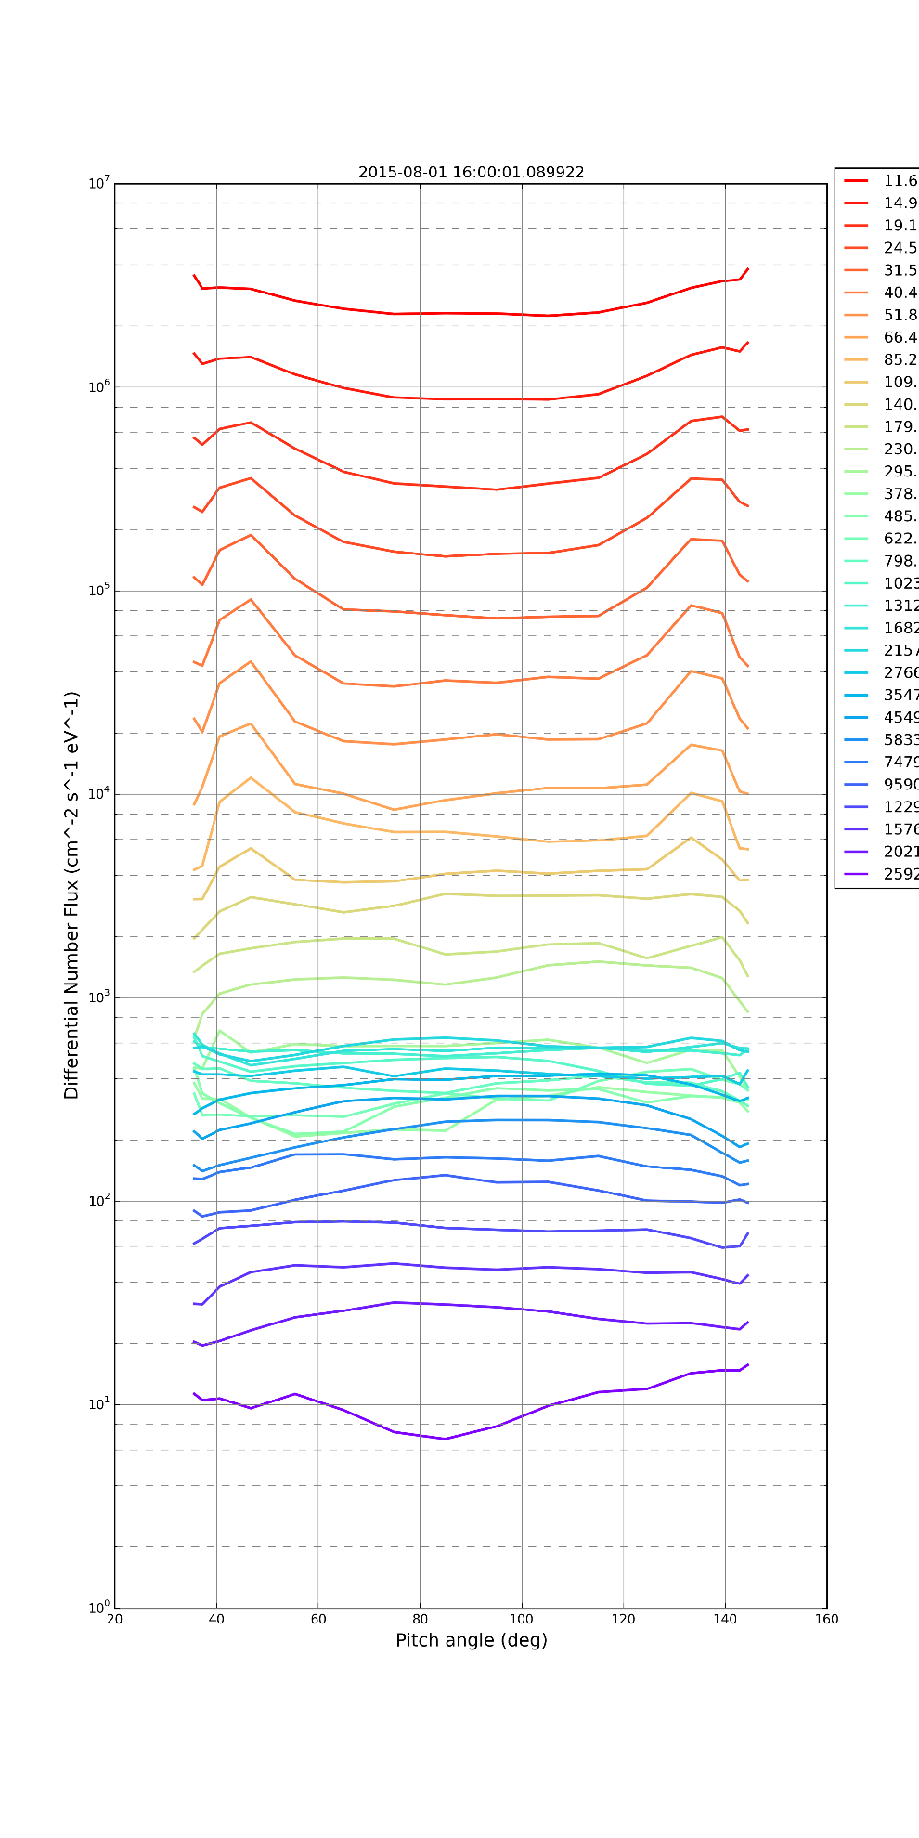

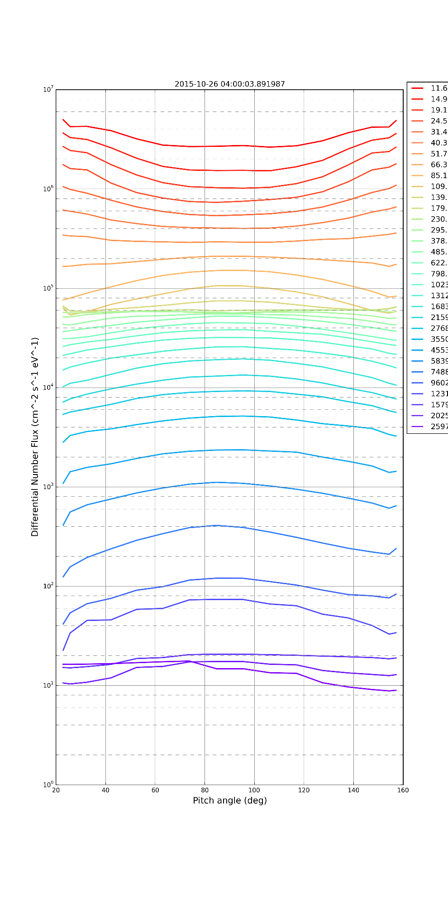

## Gyrotropy and Better Average Pitch Angles

The is a short coming in the stacked PADs that is being currently addressed. As mentioned earlier, the magnetic field doesn’t coincide with a coordinate axis, so that while pitch angles can be easily binned data about gyrotropy is lost. This leads to the need to approximate the average line used in the Stacked PADs, leading to undesirable behavior near the edges.

To fix both of these problems, a new coordinate system, called local magnetic coordinates (LMC) is being developed.

The equations for the unit vectors are:

and

Implementing this coordinate system for the Oct 26 Event gives the following distribution of instrument pixels in the LM frame:

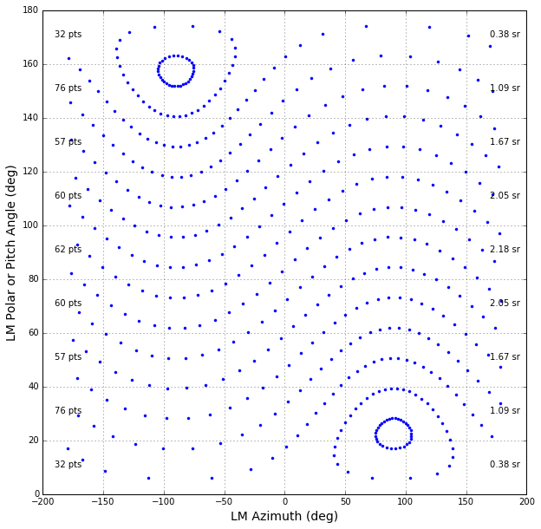

Where the annotations on the left indicate the number of pixels in each bin (e.g. 32 pts in the bin from 0-20 degree in pitch angle) and the ones on the right indicate the number steradians that bin covers.

The pitch angle distributions remain s the same and the Raw Stacked PADs looks like

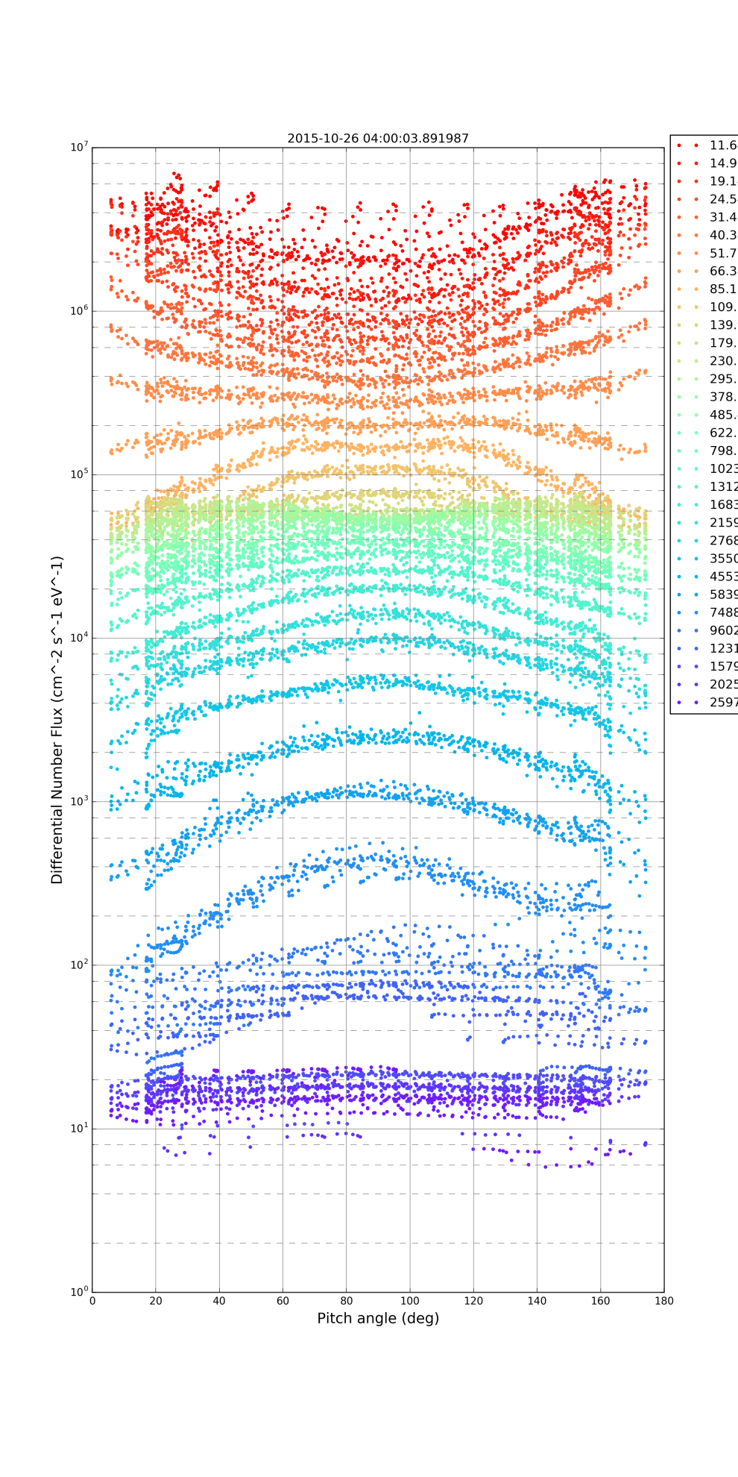

But now the new normalization for the Binned PADs looks like:

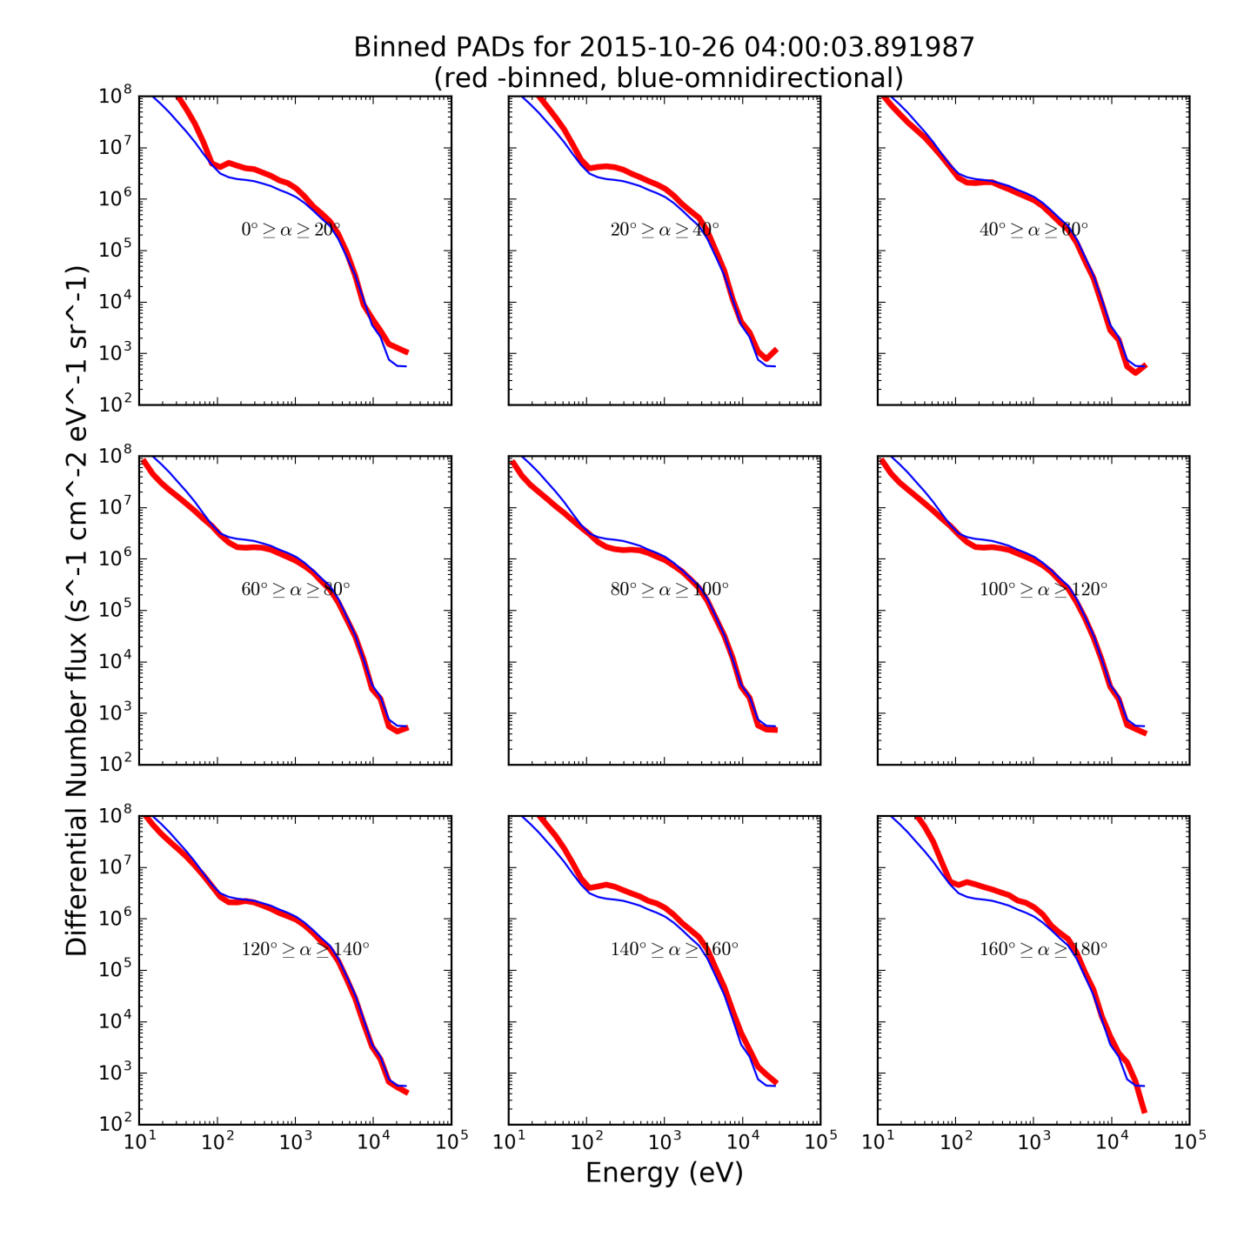

with new units of , where is the differential particle flux The method for this computation is:

where is the set of pixels in the desired bin (e.g. 32 pixels with pitch angles between 0 and 20 degrees), is the nth energy, and are the counts in each of these pixels.